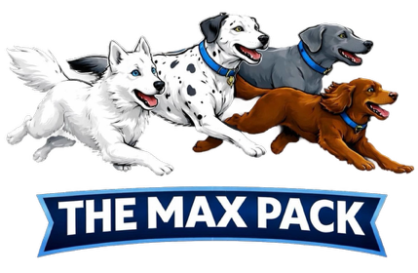
THE MAX PACK REGISTRATION FORM
This Form must be completed. Please return to us to allow booking on to your dogs first session and joining out WhatsApp groups, Thank You

Dog/Pup(s) Name(s) Age and Breed:

First Session to attend and Location:

I can confirm my dog has up to date vaccinations and flea treatment.
(This may be asked for proof at any time)

Castrated/ChemicallyCastrated/Spayed?

Rescue/From Pup/Other?

Insured? YES/NO
Is there any information or health issues that we should be aware of prior to your dog(s)/pup(s)attending?

How did you hear about us? Facebook/Friend/Dog Professional/Other
By joining The Max Pack Social Community I agree to declare if associated to another dog profession or service below:

I would like to join The Max Pack WhatsApp group for Stay & Play sessions at Market Drayton, Middlewich, Haslington. Yes/No
Please be aware we take photos and videos of the dogs during sessions for our social media.
I confirm that I have read and familiarised myself with the Rules and Regulations of The Dogs Paddocks locations on www.thedogspaddocks.co.uk and I have read The Max Pack Terms & Conditions on www.themaxpack.co.uk
Your dog remain’s your full responsibility.
Any injury or illness to dogs or persons is not the responsibility of The Max Pack.
Older children are authorised, toddlers and young children, for safety reasons are not authorised.
Balls and toys are not during sessions to reduce any resource guarding issues
Bitches in season must not attend.
Please do not turn up more than 5 minutes prior to your session, any disruptive behaviours displayed by your dog may result in you requested to leave the session. Each location has parking facilities.
Name:

Signed:

Date:

Contact Number:

Residential Location:

